INTERPRETATION & TRANSLATION SERVICES  Bridge Street, Reading, RG1 2LU. Tel 0118 937 2033 (Monday to Friday 9am to 5pm)  Out of hours 0118 9373737  Email: Interpretation.andTranslationServices@reading.gov.uk | 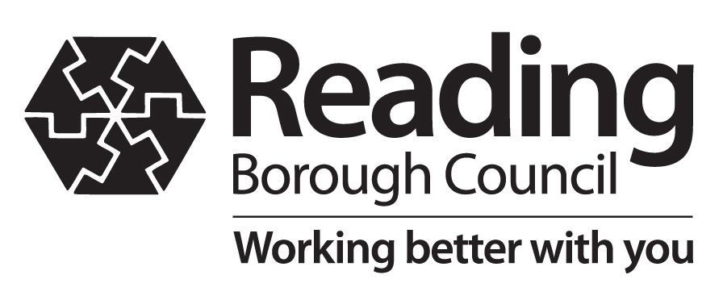
Please be aware, it can take up to 5-7 working days for an application to be processed
REQUEST FOR AN INTERPRETER – CONFIDENTIAL
(Please complete form in block capitals)

Note – For RBC office use:

Date Requested |  | Our ref |  | Chargeable | - Yes | - No

Service Requested By

Cost Code | Please invoice BOB ICB as usual – address provided below

Organisation Name

Team & Directorate

Name

Job Title

Postal Address

Postcode

Invoice Address* | Buckinghamshire Oxfordshire & Berkshire West ICB  QU9 Payables N165

PO BOX 312, Leeds, Yorkshire | Postcode | LS11 1HP

Telephone (inc STD code) |  | Fax

Mobile |  | Email

Client Details

Name

Gender: | - Male | - Female | Age (if under 16) |  | (If known)

 | - Adult | - Child | - Family

Country Of Origin

Postal Address (if applicable)

Postcode

Telephone (inc STD code)

Interpreter Gender Preference | - Male | - Female | - Either

Our ref
Language Spoken |  | Dialect

Sensory Needs
e.g Braille, signing

Additional Useful Information (Agenda, purpose of meeting, details of needs being addressed etc.) If this is a complex meeting then the interpreter needs to be briefed before the meeting, please allow time for this before the meeting and indicate on the form what time you would like the interpreter to arrive.

Appointment Details

Interpreting Date  dd/mm/yy |  | Start  Time  hh:mm |  | Finish  Time  hh:mm

Booking confirmed | Date

Venue Address

Postcode

TO BE COMPLETED BY THE REQUESTING OFFICER

Interpreter Start Time | Interpreter Finish Time | Total Hours On Site

REQUESTING OFFICER

Signature |  | Print Name |  | Date

I confirm I have provided the service requested by this form and that the above details reflect the time and travel involved
INTERPRETER

Signature |  | Print Name |  | Date

