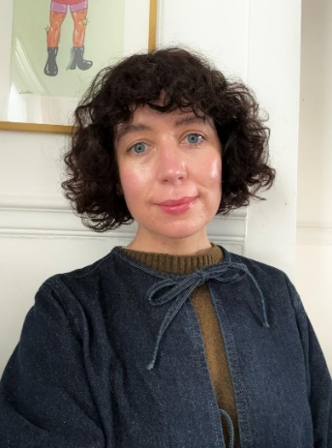
A short article from Bethany Fothergill, an optometrist with Vision Care for Homeless People, Brighton Clinic
Vision Care for Homeless People is a fantastic and vital organisation that I’m proud to be a small part of.
I decided to volunteer for VCHP as I feel that providing a skill and a little bit of time can be more beneficial than donating money to a charity. Access to eye care is so important, especially for vulnerable individuals, and as an Optometrist I’m in a position to be able to give back.
I have volunteered for VCHP for just over a year now, the other volunteers and staff at the First Base Day Centre are amazing and the people using the service are some of the kindest and most appreciative I have encountered in my 15 years of working as an Optometrist. I can always rely on having interesting conversations and once I even found myself singing along to ‘I can see clearly now the rain has gone’ with a patient and another volunteer!
If you think you might be able to give a little bit of time to volunteer, I would urge you to do so. I always leave the clinic having had a happy time and knowing that I have helped in a small way - it’s a lovely feeling.
By Bethany Fothergill, Vision Care for Homeless People, Brighton Clinic

Our VCHP Brighton clinic runs from First Base Day Centre, on a Monday morning. (St Stephens Hall Montpelier Place, Brighton BN1 3BF)
We desperately need more volunteer Optometrists and Dispensing Opticians/assistants at our Brighton clinic. If you’re able to spare a few hours to help us run this vital service, please complete a Tell Me More form available on our website: VCHP Volunteering Opportunities. Alternatively, email helen.harms@vchp.org.uk. Thank you.

